**Chapter 2 V2X communication**

As mentioned in chapter 1, V2X communication is essential in order to cooperate with C-ITS. For a common understanding of this communication, standardization organizations like IEEE has released IEEE802.11p standard for V2X communication covering PHY and MAC layers in 2010. This includes data exchange between high-speed vehicles and the roadside infrastructure, so called V2X communication. [Larsson M. Methods to Improve V2X Communications in Platoons of Heavy Duty Vehicles[D]. Halmstad University Press, 2016.]

**2.1 Wireless communication technology**

There are plenty of wireless communication technologies like cellular, Bluetooth, LTE or WI-FI, which are examined for use in ITS application. But not all of them can be satisfied for the safety-related requirement of V2X communication.

**Bluetooth:** is a standardized short range radio link technology. It can satisfy the direct device-to-device requirement, but the transmission range is less than 100m with larger delay for V2X communication.

**Long-Term Evolution(LTE):** is one promising radio access technology to be considered in the standardization work of the ITU for 4G systems.it can support highway speed and the transmission range is not limited. However, it cannot support direct device-to-device mode.

**Wireless Access for Vehicular Environments (WAVE) or Dedicated Short Range Communication(DSRC) technology:** [ Status of the Dedicated Short-Range Communications Technology and Applications: Report to Congress. U.S. Department of Transportation John A. Volpe National Transportation Systems Center, July 2015.] is the main enabling wireless technology for V2X communications.

New technologies like 5G or LTE are in development. They may also satisfy the security reliability and privacy requirements for various V2X communication.

**2.2 System architecture of V2X communications.**

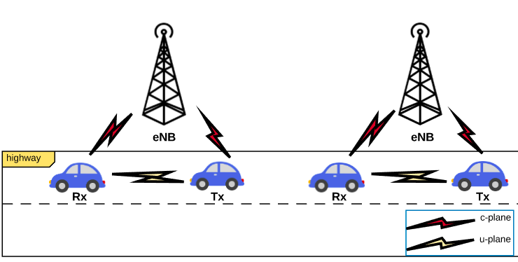

**figure.1 Vehicle to vehicle communication**

As figure.1 shows, in V2X communication system, all vehicles are connected to base station and are under the control of base stations. Also, vehicles in U-plane communicates directly from transmitter to receivers which are located in the proximity of the transmitter. So the direct V2X communication can contribute to a low-latency performance without network infrastructures.

**2.3 Scenarios**

In order to improve driving safety or traffic efficiency and provide safety-related information and abundant infotainments to the driver, V2X communication enables large number of use cases. This part introduces the use cases and shows how the use cases imply certain requirements to the system [“CAR 2 CAR Communication Consortium Manifesto,” [Online]. Available: http://elib.dlr.de/48380/1/C2C-CC_manifesto_v1.1.pdf. [Accessed 12 10 2014].

**2.3.1 test environment of our work**

Our test environment is based on highway, as we know, highway is the high-speed test environment focusing on larger mobile stations and continuous coverages. The key characteristics of this test environment are continuous wide area coverage supporting high speed. This scenario will therefore be noise-limited and/or interference-limited. [ Series M. Guidelines for evaluation of radio interface technologies for IMT-Advanced[J]. Report ITU, 2009 (2135-1).] However, we consider a more special test environment based on highway. It’s assumed that all vehicles on the highway with the same speed and the same distance with before and after vehicles.

The figure.1 involves the main parts for V2X communication. There are as following:

Driver: the drivers receive warning information and benefit from this kind of system.

Vehicle: it is the main character on the highway. Maybe in future, it will replace the driver to implement driving and connecting to others smartly.

Internet service providers: it provides internet service for vehicles and drivers. [Deshmukh N. Enhancement of Communication Model for Driving Simulators by Relevant Physical Effects of Radio ropagation[D]. Technische Universität Chemnitz, 2015.]

**2.4 Application of V2X communications**

V2X communication system is the solution to prevent drivers and passengers from road-related accidents. By using of V2X communication, all vehicles in the vicinity are connected. So the drivers can be made aware of all potentially hazardous conditions and dangerous situations through receiving warning information.

**2.4.1 safety-related application**

The main purposes of safety-related application are to reduce the occurrence of overtaking, rear-end collision, and check pre-cash situation and hazardous location.

V2X communication system is the solution to prevent drivers and passengers from road-related accidents. By using of V2X communication, all vehicles in the vicinity are connected. So the drivers can be made aware of all potentially hazardous conditions and dangerous situations through receiving warning information.

**2.4.2 safety-related application**

The main purposes of safety-related application are to reduce the occurrence of overtaking, rear-end collision, and check pre-cash situation and hazardous location.

**Safe overtaking:** Regarding safe overtaking, the use of V2X communication by its very nature requires that all vehicles in the vicinity be connected, so drivers can be made aware of all potentially hazardous conditions and situations. [Deshmukh N. Enhancement of Communication Model for Driving Simulators by Relevant Physical Effects of Radio ropagation[D]. Technische Universität Chemnitz, 2015.]

**Cooperative Forward Rear-End Collision warning:** Regarding rear-end collision, it occupies a significant percentage of all accidents. The cooperative forward rear-end collision warning provides assistance to drivers to avoid rear-collision with other vehicles. In order to avoid a rear-end collision, each vehicle transmits own information such as location and speed to others, and monitors continuously the position and behaviour of other vehicles in the proximity of itself. Thus, this will give the driver enough time to react and avoid rear-end collision.

**Pre-cash Situation Sensing:** This situation is similar to the cooperative forward rear-end collision warning. This requires all vehicles periodically share information to predict a crash. Under this situation, we assume this is an unavoidable crash that is no enough for driver to steer or brake. This requires vehicles exchange more detailed position data and situation. Also, extra information like air bags and seat belts need to be optimized.

**Hazardous Location Notification:** Regardinghazardous location, V2X communication system share information related to dangerous location on the roadway, for example, frozen and slippery highway, rolling stones or potholes on the roadway. Therefore, it is urgent to generate the information about exact location and broadcast to vehicles. So if a vehicle experiences the situation of its system, it will share the information with other vehicles in its proximity. So the driver will receive the notification automatically, and pay attention to this hazardous location and avoid accident. [Deshmukh N. Enhancement of Communication Model for Driving Simulators by Relevant Physical Effects of Radio ropagation[D]. Technische Universität Chemnitz, 2015.]

**2.4.3 Efficiency-related application**

Efficiency-related application in V2X communication system considers improving the efficiency of transportation network through sharing information to the drives or reducing energy consumption. The more efficient the transportation network is; the less delay of transportation system is.

**Fast Pass the Tollbooths:** when vehicles get close to these tollbooths, the drivers will receive information collected from other vehicles. Then they can decide which one is better with less vehicles. So these vehicles can pass the tollbooths with less time.

**Enhancing Navigation and Mobility:** Vehicles uses the information constantly collected from others regarding the traffic congestion on the roadways over large area. Then, the vehicle utilizes the information about current traffic conditions through the area to decide the optimal route, which increases the mobility of the roadways.

**Reducing Energy Consumption:** As mentioned before, with enhancing navigation, the vehicle can find a better route with less traffic congestion and less delay. Also with high mobility, the energy consumption is decreased at the same time.

**2.4.4 Infotainment**

In V2X communication system, infotainment can enable groups of cars to exchange multimedia information. Such as sharing Mp3 songs or having a phone call.

**2.4.5 others application**

Also, V2X communication can support economic development. With such an abundant communication system, we believe it will bring economic benefit.

**2.5 Drawbacks and challenges of V2X communication**

**2.5.1 Drawbacks**

**Data load:** One drawback identified by the researchers themselves is that the data load of the channel increased rapidly when groups of vehicles are about to meet.

**Hardware equipment:** Under certain complicated scenario, if the vehicles are not equipped enough hardware to detect and sense current environment, or the connection to the internet is lost for any amount of time. The V2X communication could not be efficient as expected. [Weston L, Marrero Reyes J. Driver Safety Alert System-An Alternative to Vehicle-to-Vehicle Communication-based Systems[J]. 2016.]

**Amount of time:** If all vehicles in V2X communication system benefit from this system, the amount of time will be the biggest issue.

**2.5.2 Challenges**

**Complex scenarios:** In real world, there are too many scenarios that we expect, and most of them are complicated and hard to analyze.

**Low usage:** Rarely real V2X communication system have established in the market, even the top ranked auto companies have no communication systems and protocol be installed in their vehicle.

**Regional standard:** And the big challenge is that the standard just regional standard which cannot obtain consensus on the same point in a short time.

So we still have a long way to go for V2X communications. But some initiate product has been established in the market.